1. ***Joint abstract***

Analysis of trophic webs based static predator-prey relationships allows for accessible modeling of web robustness, diversity, and other computational characteristics. In addition to surveying such graph-wide traits and distributions of nodal characteristics, herein a novel dynamic extinction method is investigated to better compare an Arctic (Kongsfjorden) and an Antarctic (Potter Cove) trophic web. Broad metrics, such as modularity and connectance, and nodal metrics, such as Keystone Species Indices (KSI) and trophic levels, are computed to provide context for interpreting extinction simulation results. Six extinction events are simulated, extinguishing species by highest, median, and lowest KSI and trophic level. In five out of six simulations, the Antarctic web survived a higher percentage of dynamic extinction events. Despite the Antarctic’s lower modularity, through its higher connectance and lower trophic concentration, it was consistently able to handle perturbations better than the Arctic web. Such dynamic extinction simulations also call into question the accuracy of KSI as a metric seeing as how many low KSI extinctions caused grave secondary extinctions. Future work needs to be performed to validate the realism of the proposed dynamic extinction method. Nonetheless, this work introduces a methodology that may provide insight towards how static trophic webs can restructure and that can be used to topologically compress graphs of other types.

Neural networks are powerful models that drive the current AI revolution, yet optimizing their architecture remains niche to each task and under constant improvement. This work extends the dynamic extinction methodology –particularly by lowest KSI– to topologically compress neural networks. The analyzed trophic webs are translated into neural networks, fully connected networks are created as points of comparison, and both are tested on basic machine learning classification tasks. Thorough testing reveals that, not only do the trophic networks function as neural networks, the trophic network without cycles –that being the Arctic– outperformed the baseline model in simple classification tasks at maximum compression with moderate training and moderate classification tasks at moderate compression with moderate training. The Antarctic neural network’s relatively poorer performance reveals an architectural difference in energy and information transfer attributed to the prominence of cycles within the Antarctic trophic web. Further work needs to be done to test the Antarctic network in better suited time-series tasks that employ its recurrent structure. More robust testing needs to be performed to better understand the advantages posed by trophic-inspired neural networks and topological compression to extinction simulation. This combined work nonetheless shows the efficacy of pre-training neural network compression in creating useful models and the viable performance of trophic nets.

1. ***Joint introduction***

Studying food web robustness and characteristics can provide insights into how strong or weak trophic networks are to possible perturbations. Varied works attempt to model this robustness. Some works employ the Lotka-Volterra population-time model and consider field data of population counts, biomass, and changing environmental factors to predict future population counts and fluctuations in energy transfers. Other works investigate static graph properties, considering a constant original adjacency matrix of whom-eats-whom and calculating nodal and graph-wide metrics to conceptualize how strong a food web may be. This work intends to fuse both latter by bringing a dynamic nature to typically static analyses.

The principal objective sought through this experiment is obtaining a narrow quantitative comparison of an Arctic and an Antarctic trophic web through an original static trophic web. These marine polar opposite regions are of critical importance, as they face the brunt of climate change in the effects of ocean acidification, ocean warming, and glacial melt. Understanding how these webs are structured and how they respond to perturbations can inform policy and conservation efforts in protecting these regions.

While studies such as Griffith et al. (2019) focus on broad web-wide characteristics like resilience in the polar regions, graphical traits and distributions of nodal characteristics will only be investigated preliminarily to heuristically understand the structures of each trophic graph. Thereafter, novel dynamic extinction events will be simulated in each web to understand the resilience of each web, track nodal traits as species are extinguished, and identify if there are important species initially overlooked by KSI or trophic level metrics. These extinction events will simulate perturbations caused when removing species of highest, median, or lowest KSI and trophic level. These simulations will also open a vision of the fundamental connections and true backbones of each respective web. Such nodal and extinction analyses between each polar trophic web, as included in this work, will contribute to the broader scientific base of comparing ecological (and specifically trophic) characteristics between opposite polar regions and understanding how to best model the robustness of trophic networks.

An emerging field of trophic network research revolves around developing neural networks, such as graph neural networks, to model population models or trophic interactions with respect to time, leveraging the inference power of machine learning to inform ecological decisions. However, inspired by the dynamic extinction simulation method developed in this work and its ability to topologically compress graphs graph, a secondary, interdisciplinary objective of this work is to do the inverse: that is, imitate varied trophic web architectures into neural networks. Within the realm of artificial intelligence, optimizing the arrangement of neural networks is a persistent challenge with no closed-form solution. And although Winiwarter (2007) theorizes that there are close analogies between food webs and neural networks, few works practically explore using the topology of these food webs as a basis for optimizing neural network topologies—the closest study uses trophic principles to consolidate feature inputs for ecological modeling the (Concepcion II et al., 2020). In this work, two naturally occurring trophic networks of different topologies will already be investigated. Moreover, through simulating the extinction of lower-impact species within each web, simplified stable trophic webs retaining similar backbones of decreasing complexity will be created for each trophic web. Neural networks of identical form to each trophic webs will be thus designed, training each on common machine learning datasets and comparing them to baseline models with near identical edge counts. If these networks based on trophic webs can be trained faster, or retain higher accuracy levels at simpler levels, these results could have valuable implications for increasing AI efficiency.

Part 1: Trophic Analysis

1. ***Methods***

To thoroughly analyze the differences between the Arctic and Antarctic trophic webs provided, a variety of methods were used that can be classed into (a) broad-level network wide metrics, (b) calculations and distributions of node-level traits, and (c) dynamic extinction simulations for resilience-testing. All analysis was conducted in Python 3.11.11 using principally the libraries igraph (Csardi and Nepusz, 2006) and scitkit-learn (Pedregosa et al., 2011). Perplexity, ChatGPT, and GitHub Copilot were all used to assist with code generation, debugging, and guidance when performing these analyses.

The trophic networks are initially obtained as predator-prey relationships or adjacency matrices, as are common for the field (Pawluczuk and Iskrzyński, 2022), with the Potter Cove food web from the Antarctic taken from Rodriguez et al. (2022) and the Kongsfjorden food web from the Arctic taken from Griffith et al. (2019). Each food web was translated into an igraph object using the Pandas library. Repeated “parallel” connections described within each CSV were ignored.

The following broad level metrics were computed for each graph: number of nodes, number of edges, basal species count, apex species count, graph-wide connectance, modularity, cumulative degree distribution (CDD), CDD fit, and average degree. The first four metrics were achieved through standard igraph methods and properties. The modularity of the graph was obtained using the Leading Eigenvector method, which is provided within the igraph package. The cumulative degree distribution (Sayama, 2021), is computed through the following formula:

$$C\left(k\right)=\sum_{k^{'}=0}^{k}{P\left(k^{'}\right)}$$

…where $P\left(k^{'}\right)$ is the probability of a given degree within the graph. Sklearn’s **curve_fit()** is used to test varied function models, with the best selected by AIC. The connectance of the graph is computed through the following formula (Dunne, Williams, & Martinez, 2002):

$$C=\frac{L}{S^{2}}$$

…where $L$ is the number of links within the graph, and $S$ is the total node count.

More prominently, this work expands on nodal analyses promoted by other works (Cirtwill et al., 2018) by calculating both the KSI and trophic species distributions for each graph. In this work, KSI is defined using PageRank (Page, Brin, Motwani, & Winograd, 1999), degree, and betweenness—all of which are readily defined within igraph. All species are ranked according to these traits, and the value of the three ranks for each species are averaged together and divided by the total species count to compute (Scian et al. 2025) and normalize the KSI values across graphs. Since basal and apex species are unable to exhibit betweenness, all these species are awarded the average betweenness of the graph, whose computation *includes* prior betweenness values of zero, reducing the penalty. To compute the trophic level of each species, a set of linear equations are defined (Johnson et al., 2014) and solved with NumPy’s linear algebra solver. Basal species with no inputs are defined as a trophic level of 1. If the graph fractures into subgraphs, the trophic level is calculated for each species in its respective graph. A regularization identity matrix is added to avoid singular matrix errors with the solver.

Additionally, the roles of each species are defined within a parameter space with axes of “Within-Module Degree” (Z) and “Among-Module Connectivity” (C) (Cui et al., 2019). The bounds that define how roles are assigned are set to Z = 2.5 and C = 0.62 (Guimerà & Amaral, 2005). The Z score for a given node is computed by normalizing the Within-Module Degree with the following formula (Guimerà & Amaral, 2005):

$$Z_{i}=\frac{ⅆ_{i}-μ}{σ}$$

…where $μ$ is the mean degree of the module the current node pertains to, and $σ$ is the standard distribution of degrees within the same module. Module classifications are made according to the Leading Eigenvector method due to its determinism. The C score for a given node is defined by (Guimerà & Amaral, 2005):

$$C_{i}=1-\sum_{s=1}^{N}{{\left(\frac{k_{is}}{k_{i}}\right)}^{2}}$$

…where $N$ is the number of modules, $k_{is}$ is the number of links between the current node and nodes of module $s$, and $k_{i}$ is the total degree of the current node. Once these metrics are obtained, the following roles are assigned based on the position in the C-Z space of a node (Rodriguez et al., 2022): (a) “Module Specialist” if Z < 2.5 and C < 0.62, (b) “Module Hub” if Z > 2.5 and C < 0.62, (c) “Module Connector” if Z < 2.5 and C > 0.62, and (d) “Network Connector” if Z > 2.5 and C > 0.62. These roles have been empirically validated and follow accepted results of other works (Guimerà & Amaral, 2005).

Prior works explore using static extinctions (in a variety of sequences) to characterize the resilience of graphs (Cordone et al., 2018) or see how graph-wide characteristics like connectance vary (Salinas et al., 2024). This work investigates graph-wide resilience and node-level importance through dynamic extinction simulations. This work performs six dynamic extinction simulations for both the Arctic and Antarctic trophic webs, extinguishing species based on having either the highest, median, or lowest value of KSI and then trophic level. Each extinction is “dynamic” as the evaluated metric (of either KSI or trophic level) is reevaluated after each individual extinction, and only one species is extinguished at a time. Secondary extinctions will be caused if less than $X$ percent of the original in-links to a species remain, where $X$ is the extinction threshold (Cordone et al., 2018). In this work, $X$ is constantly held at 50% for all extinction simulations. The percent of the original population forcibly extinguished, thus not including secondary extinctions, is plotted on the X axis, while the percentage of the original population left is plotted on the Y axis. When instantiating dynamic extinctions by trophic level, if there were ties between species of a certain trophic level (as happened when extinguishing by lowest trophic level), the highest-degree species of such trophic level was extinguished first.

The KSI of all species are also plotted with respect to extinction events, allowing for viewing of how the extinction of species in a certain order changes how “keystone” a species might be. The graphs generated by the given Python script were coded to be interactive, allowing for the user to (a) click on a given species’ KSI to highlight it and see what species it belongs to, (b) type in a species’ name directly to find its KSI, and (c) type in the X-coordinate of a given point to view what species was forcibly extinguished in that moment.

1. ***Results***

|  |  |  |
| --- | --- | --- |
| **Metric** | **Antarctic** | **Arctic** |
| *# Species* | 110 | 164 |
| *# Links* | 660 | 852 |
| *Connectance* | 0.05454 | 0.03168 |
| *Avg. Degree* | 6.0 | 5.195 |
| *CDD Fit* | Exponential | Log normal |
| *Modularity* | 0.2617 | 0.3172 |
| *KSI Mean* | 0.1026 | 0.06337 |
| *KSI STD* | 0.1586 | 0.1133 |
| *Trophic Mean* | 2.278 | 2.864 |
| *Trophic STD* | 0.9883 | 1.041 |
| *Network Connectors* | 0.9091% | 0.6098% |
| *Module Connector* | 41.82% | 20.73% |
| *Module Specialist* | 56.36% | 77.44% |
| *Module Hub* | 0.9091% | 1.220% |
| *# Basal Species* | 30 | 12 |
| *# Apex Species* | 5 | 41 |

**Table 1**: Graph-wide metric comparison between the Antarctic and Arctic Trophic Webs

Table 1 displays the graph-wide metrics computed for both graphs, where notable differences can be observed. The average degree of a node in the Antarctic web is 15.50% greater than the average Arctic degree. The Antarctic web has more than double the percentage of Module Connectors as the Arctic web but has less Module Specialists than the Arctic. This is corroborated by the Arctic web having a higher modularity than the Antarctic web. The Arctic web also has a higher average trophic level than that of the Antarctic web. Finally, the Arctic web has more than 8 times as many apex species as basal species, while the Antarctic web has more than double as many basal species as apex species.

|  |  |
| --- | --- |
| **Species participation in graph cycles** | **Percent of graph cycles present in** |
| Hydrozoa | 69.11% |
| Euphausia superba | 50.90% |
| Salpidae | 50.90% |
| Nereididae | 48.20% |
| Polynoidae | 47.98% |
| Cephalopoda | 42.39% |
| Nemertea | 35.32% |
| Hyperiidea | 31.30% |
| Priapulida | 26.34% |
| Polychaeta | 22.79% |
| Zooplankton | 0.08% |
| Copepoda | 0.08% |

**Table 2**: Percent of Antarctic graphical cycles that each Antarctic species is located on. All excluded species are not located on a cycle path. Note that cannibalistic cycles were removed prior to this analysis.

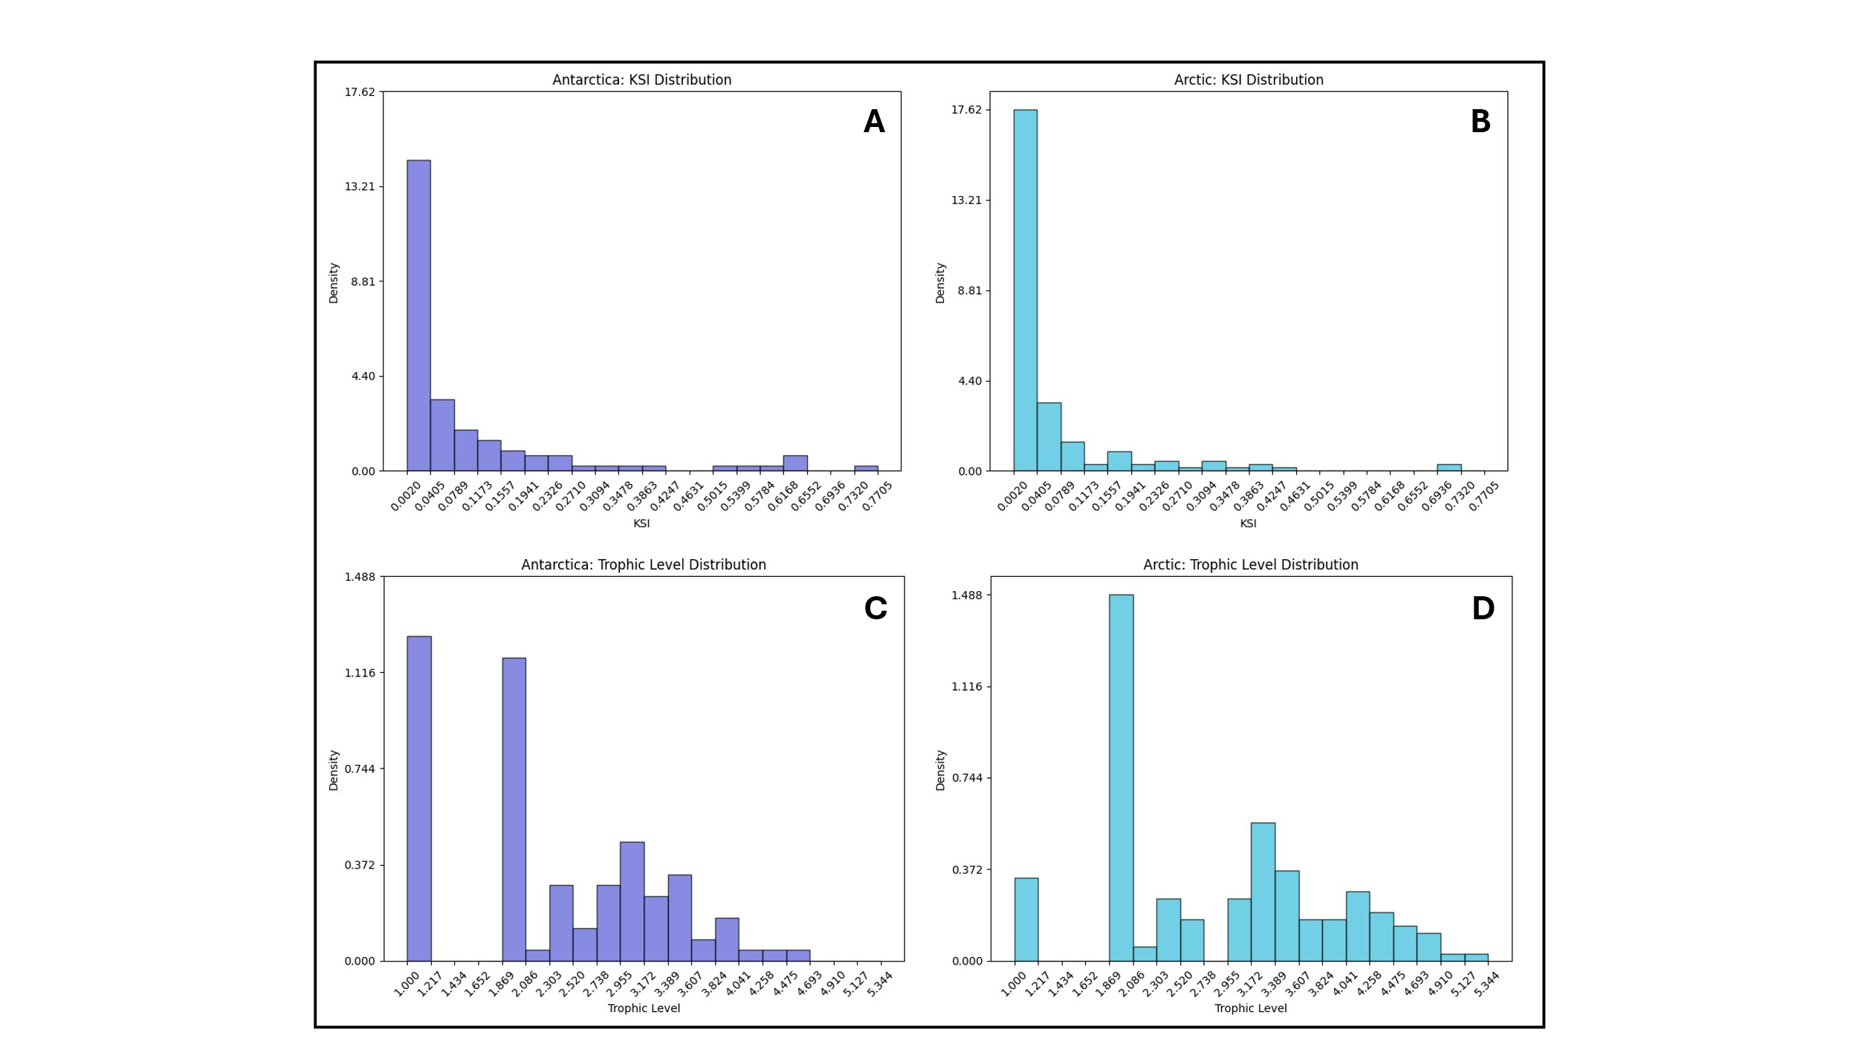When removing cannibalistic cycles within both food webs, the Arctic food web remains with no cycles, whereas the Antarctic web retains certain cycles. Table 2 demonstrates the percentage participation of each species that occurs in at least one cycle in all the present cycles within the graph, with certain species appearing more often than others.

**Figure 1**: Node-level metric distributions across both trophic webs; (A) KSI distribution of Antarctic Trophic Web; (B) KSI distribution of Arctic Trophic Web; (C) Trophic Level distribution of Antarctic Trophic Web; (D) Trophic Level distribution of Arctic Trophic Web

The Antarctic trophic web has a smoother distribution of KSI along the lower level, and also includes a group of high-KSI species spanning 4 bins in the latter half of the graph. The Arctic trophic web has a higher density of species in the lowest KSI bin, and only has one high-KSI bin with a relatively low density. As it pertains to trophic level distribution, the Antarctic web trophic levels are less disperse and consolidate at a lower mean than the trophic levels of the Arctic web. Moreover, the Antarctic web has a much higher density of basal species while still having a comprobable density of primary consumers relative to the Arctic web.

The following 6-graph figure presents the results of all extinction simulations. Certain KSI lines are deliberately highlighted to showcase KSI extinction trends.

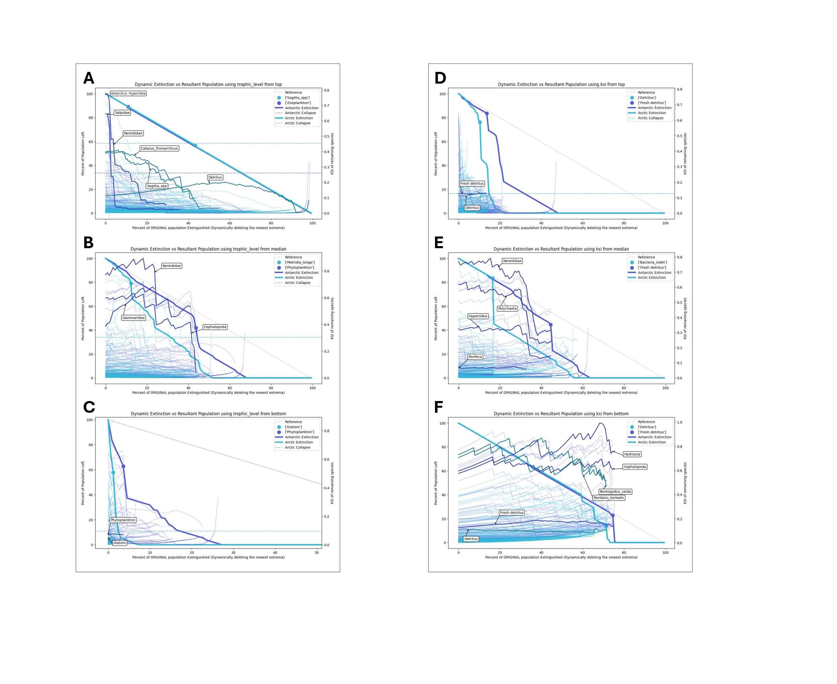

**Figure 2.I**: Extinction simulation results for both trophic webs when dynamically extinguishing by trophic level; smaller lines are plots of KSI for all species, measured by the right-hand axis. (A) Extinction by highest trophic level; (B) Extinction by median trophic level; (C) Extinction by lowest trophic level (ties broken by extinguishing higher degrees first).

When dynamically extinguishing the highest trophic level species, there are minimal secondary extinctions, as species with few dependencies are removed in sequence from the top. No species created a significant drop in either population when popped. In both food webs, species with high KSI instantly decreased when higher trophic level species were popped, even without secondary extinctions occurred. This decrease was markedly larger for the Antarctic species than the arctic species, particularly when **Hyperiidea** was eliminated. Arctic species, particularly those of a mid-range KSI, sustained their KSI throughout more extinction events and did not decrease as quickly. In the case of the arctic, the KSI of **Detritus** increased overtime and became the keystone species when most of the remaining species were basal and primary consumers.

When dynamically extinguishing the median trophic level species (wasp-waist extinction), the output of this simulation was not deterministic, due to rounding errors and tie-breaking that resulted from random ordering of the igraph vertices. After forcing intermediary rounding and setting low threshold cutoffs when handling tying, the simulation output converged to the provided graph. In this graph, the Antarctic web again exhibits sharp decline in the KSI of high-KSI nodes without a corresponding drastic collapse of the web. In this simulation, this first Antarctic KSI drop occurs near x=20%, where the species exterminated is **Gammaridea**. A second significant Antarctic KSI drop occurs near 43% due to the extinction of **Nereididae.** This magnitude of behavior of many high-KSI species dropping in KSI is yet to be expressed by the arctic web. Looking at population trends, within the arctic web, sharper population drops were experienced earlier, and the loss of population followed a steeper slope than in the Antarctic.

When dynamically extinguishing the lowest trophic level (removing basal producers in descending order of degree), both webs exhibit early and fast decomposition, due to the inability of a food web to exist without primary producers. The Antarctic trophic web sustains longer survival due to the higher percentage of primary producers it has compared to the arctic web. The largest population drop in each respective web came as a result of extinguishing **Diatoms** in the Arctic and **Phytoplankton** in the Antarctic. However, the second largest population drop in both webs was caused by Fresh Detritus (Antarctic) and Detritus (Arctic), species that cause the most significant population drops in the KSI-based extinction simulation.



**Figure 2.II**: Extinction simulation results for both trophic webs when dynamically extinguishing by KSI; smaller lines are plots of KSI for all species, measured by the right-hand axis. (D) Extinction by highest KSI; (E) Extinction by median KSI; (F) Extinction by lowest KSI

When dynamically extinguishing the highest KSI species, in both trophic webs, the removal of **detritus** (dead organic matter) yielded the highest volume drop of the population. In the Antarctic web, this was specifically **Fresh Detritus**. However, the KSI’s of both detritus populations remained relatively stable in the presence of dynamically extinguishing the higher KSI species. In this simulation, the Antarctic population held on for almost twice as long as the Arctic. Nonetheless, both populations were completely extinguished before 50% of the original population count was dynamically extinguished.

When dynamically extinguishing the median KSI, a similar visual to extinction by median trophic level was produced. Like Figure 2A and B, when a particular species was extinguished, high-KSI Antarctic species experienced a plummet in KSI without significant losses to the total population. In this case, the species was **Porifera** near the 33% mark. Both the Arctic and Antarctic population curves in this median-KSI simulation encountered a steep drop later coupled with two small drops before complete web decomposition. For the arctic, the key species that triggers a 40% population drop is **Bacteria Indet** (unidentified). In the Antarctic, the key species that causes a drop is **Fresh detritus**, and these secondary extinctions occurred later than in the Arctic case. In both webs, very-low KSI species began to lift in value at the end to shift into the spaces being extinguished.

When dynamically extinguishing the lowest KSI, there are few secondary extinctions for around the first ¾ of the extinctions due to the poor connectedness of the low KSI species. However, since the distribution of KSI is dispersed throughout each network and does not remove nodes from high trophic levels to low trophic levels, there comes a critical point in both webs where the webs are completely secondarily extinguished. This critical point was with **Detritus** for both webs, particularly **Fresh Detritus** in the Antarctic. Similarly to dynamic elimination of top-KSI, both detritus species maintained a low-middle KSI throughout most of the entire extinction simulation, which was nonetheless above the very-low KSI species in both networks. In the Antarctic web, high-KSI species retained their value at the end of the simulation until they died. In the arctic web, these high-KSI species ended with a notably lower KSI value. Both sets of high-KSI species exhibit a ramp-behavior, where their KSI’s increase steadily, drop to a critical species, and then attempt to recover.

1. ***Discussion***

Looking into the graph-wide metrics, it appears that the Antarctic web is shorter along the trophic-level axis and less modulous, wheras the Arctic web is longer along the trophic axis and more distinctly separated into modules. Moreover, the Antarctic web is more densely interconnected than the arctic web, as apparent in its higher average degree and connectance. This is corroborated by the module assignments between each network: the Antarctic web has twice the percentage of module connectors as the Arctic web, but significantly less module specialists membership. The distribution of KSI and trophic level between the two graphs also show the compactness of the Antarctic network. Figure 1C, D show that, visually, the Antarctic has a lower mean and more densely clustered distribution of trophic level than the Arctic. Moreover, the Antarctic has a smoother KSI distribution than that of the Arctic, possibly suggesting a more balanced distribution of importance.

It is theorized that a lower modularity will result in a less-resilient food web to extinction (Gilarranz et al., 2017). However, the included results show that there are more factors at play when evaluating resilience of networks and that a lower modularity does not necessitate a weaker structure: in five out of six simulations, the Antarctic web survived for longer than the Arctic web, with extinction by highest trophic level resulting in a tie. This may suggest that, although the Antarctic web expressed lower modularity, the strength of its interconnectivity was able to dampen perturbations throughout extinction better than the modularity of the Arctic web.

The Antarctic web’s higher connectance seems to enable its higher resilience in this case. Ample literature regards connectance as an important basic metric when evaluating the robustness of a trophic web (Keyes et al. 2024), especially when considering most realistic extinction models (Dunne & Williams, 2009). Dunne et al. (2002) mentions both that removal of lower-connected species and a higher graph connectance value can push off the extinction point of a web, both of which were clearly displayed in Figure 2F. Although in this work connectance may present a direct connection to the superior stability of the Antarctic network, whether the metric of connectance relates directly to network stabilty is nonetheless a contested topic (Landi et al. 2018).

When testing these webs under extinction simulations, although the Antarctic web was able to consistently sustain itself for longer, in many cases it expressed more abrupt drops in population than the Arctic web. On the other hand, prior to sharp extinction events, the Arctic web sometimes exhibited “warning secondary extinctions”, such as in Figure 2 B, D, and F. This may suggest that, in a real world scenario, there would be less signs preceeding sharp drops in population due to secondary extinctions in the Antarctic, requiring more analysis and care when making decisions that could endanger the involved species.

Looking more closely at the Antarctic web when undergoing the extinction simulations, it is worth noting that in every simulation, the extinction that resulted in the sharpest drop in population was a basal species (this excludes extinction by highest trophic level, as no notable secondary extinctions occurred). This may suggest that the Antarctic trophic web exhibits bottom-up control, where the basal species carry the most significance, aligned with how the Antarctic contains highly productive marine environments.

Beyond a greater dependence on basal species, a notable trend that the Antarctic web exhibited was having significant drops in KSI without significant drops in population, namely in Figure 2A. This appears to be due to the cyclical nature of the Potter Cove web. In Table 2, it is seen that Hyperiidea –the species that dropped peer KSI values when extinguished– occurs in 31.30% of cycles, while the two highlighted high-KSI players whose KSI drastically dropped, Salpidae and Nereididae, occur in 50.90% and 48.20% of cycles respectively. A reasonable explanation to this KSI drop could be that a cycle containing many high-KSI players was severed, bringing all KSI values down. This simulation thus demonstrates that cycles within food webs may result in KSI dependencies among species, raising the KSI values of all the species involved. Conversely to seeing great drops in KSI without steep population drops, Figure 2C,E show a greatest population drop caused by a lower KSI species. Considering these dual observations, this may suggest that a keystone species index alone is not a complete metric for identifying the importance of a species with respect to maintaining a web’s livelihood, as also suggested in Valls et al. (2015).

Looking more closely at the Arctic extinctions, it is apparent that they do not exhibit such stark KSI drops as that of the Antarctic web, likely due to the lower distribution of KSI across all of the Arctic species. However, the Arctic did showcase a drop in KSI when experiencing certain major population losses, such as at 18% extinction in Figure 2E. Moreover, in Figure 2A, the Arctic web showed its ability to rearrange: the Detritus population grew from a mid-tier KSI player to become the highest KSI species across both webs. This may suggest that the Arctic web is able to reorganize itself towards a dependence on basal species, wheras the Antarctic web is already structured around their importance.

The most noticable trait about the Arctic extinctions are the steeper population drops, showing the Arctic to be less robust than the Antarctic web. This is especially visible when extinguishing by lowest trophic level in Figure 2C, where the sheer lack of basal species in the Arctic compared to the Antarctic causes the Arctic web to be fully eliminated in a third of the time as the Antarctic. Considered in the context of climate change, glacial melt and ocean warming –both of which can present unideal conditions to photosynthesizing basal species through stratifying water masses and introducing contaminants—seem to pose a greater threat to the Arctic web due to such bottom-up fragility, as described in Niedzwiedz et al. (2024).

However, although these biomes are of polar opposites, they express an uncanny similarity with their dependence on detritus. In both of these food webs, the extinction of detritus was the extinction that caused the most greatest drops in population across all simulations: for the Arctic web, it resulted in 2 greatest drops, and in the Antarctic web it resulted in 3. This could confirm how valuable both of the polar regions are as carbon sinks in their ability, dependence, and restructuring of networks around dead matter.

In both webs, it was apparent that the KSIs of most species experienced some sort of shifting dependent on which species were extinguished in the present moment, alluding to the ‘restructuring’ nature of food webs upon experiencing perturbations seen in other works (Dunne et al. 2002). In fact, in Figure 2F, when extinguishing by lowest KSI, it is apparent that many species of high KSI either approximately maintain their KSI or even increased their KSI until their respective food web is completely eliminated. Moreover, this extinction simulation allowed for preserving keystone species and thus the broad backbone of the graph, along with causing few secondary extinctions up until the critical point at 75% extinguished. Thus, by providing a method of retaining a web’s structure architecture while still compressing the entire network linearly until said “critical point”, extinction by lowest KSI is hence investigated as a method for neural network compression.

Part 2: Neural Network Translation

1. ***Methods***

*Infrastructure*

In this work, both presented trophic web graphs were also converted into respective neural network topologies, to investigate if (a) food web topologies can successfully train as neural networks, potentially with higher accuracy for certain tasks, and if (b) emulating nodal extinctions in each of these networks can provide an efficient method of topological network compression. All machine learning research was conducted in Python using Pytorch (Paszke et al., 2019), igraph, and Scikit-learn. Perplexity, ChatGPT, and GitHub Copilot were all used to assist with code generation, debugging, and guidance when developing included methods.

Prior to converting the investigated food-web graphs into neural networks, each of the graphs were pre-processed with the following criteria. Firstly, all cannibalistic connections were removed, resulting in the arctic network turning into a Directed Acyclical Graph (DAG) graph, allowing the Antarctic network to retain its cycles and leaving at least the Arctic graph without cycles. Secondly, the ratio of basal species (inputs) to apex species (outputs) was forced to be the same or inversed between the Arctic and Antarctic graphs. This was accomplished through targeted extinctions: in the Arctic graph, the apex species with the lowest trophic level were dynamically extinguished from the graph until 24 apex species and 12 basal species were left. This tactic was employed due to the high variance of trophic levels among Arctic apex species, with the intention of consolidating the apex species to a higher trophic level and thus creating more network complexity by forcing longer paths from the basal species. In the Antarctic graph, the apex species with the highest trophic level were dynamically extinguished from the graph until 13 apex species and 30 basal species were left. This tactic was employed due to the initial low count of apex species—by extinguishing top predators, a higher volume of apex species emerged. Thereafter, in the Antarctic graph, two artificial apex species were created to complete the 2:1 basal-apex ratio. These apex species were assigned to the average-sized module, forced to have an in-degree of the average of all apex predators, and had a ratio of in-module out-module connections as close as possible to the average of their assigned module.

Hence, the Arctic graph was left with an input-output ratio of 1:2, and the Antarctic graph was left with an input-output ratio of 2:1. These ratios were intentionally matched for possible future comparison of how well each graph functions as a neural network. For direct comparison, the graph edges in either graph can be completely reversed to change a 1:2 ratio to a 2:1 ratio—however, reversing the hierarchical structure in this manner may dismantle its representation as a food web (Rodgers et al., 2023) through changing the nodes that control the network without allowing for natural restructuring.

Matching these ratios does not mean that the graphs can be directly compared, as the number of inputs and outputs in each graph is different: the ratios 24:12 and 30:15 cannot be directly compared without scaling the networks to a common multiple of inputs and outputs. As such, a horizontal concatenation function, **horzcat_graph()**, was created to allow each graph to be scaled, by: (a) duplicating all existing nodes and edges and (b) replicating inter-module edges between new modules and old modules. This allows for the graph to retain its modularity and retain its interconnectedness when scaled.

To complement **horzcat_graph()**, **vertcat_graph()** was created as a function to sequentially cascade graphs, allowing for division or multiplication of input-output ratios. This function merges two graphs by replacing the input nodes of one graph with the output nodes of the prior. This function orders both the basal and apex indices by degree and matches them accordingly.

A custom **Network** class was created to allow for direct neuron connections to be manipulated and break the traditional layered format of network architectures. The Network class contains a square matrix of weights, which is the adjacency matrix of the graph with trainable weights at each “1”. The indices of the input and output neurons within this matrix are defined during the creation of the network. To compute each forward pass, a complete matrix multiplication is iteratively computed between an input matrix and the weight matrix, and the resultant is redefined as the input matrix. For DAG networks, this matrix multiplication is performed as many times as the longest length from the input neurons to the output neurons. For cyclical networks, this computation is performed **max_iters** times or until the value at the output neurons converge below a given **convergence_threshold**, akin to the network convergence explored in Lippl et al. (2023). The **Network** class was optimized for batch training, parallelized with CUDA for an Nvidia RTX3060 GPU for faster training.

The function **graph_to_nn()** was created as a method to transform each graph into a neural network using these classes. In all networks, a dense layer is added before the graph inputs and after the graph outputs to match the dimensions of the data being trained on and avoiding architectural biases from hindering learning for the trophic web networks. A dense layer allows for all graph inputs to be connected to every datastream input, allowing for a random routing of datastream inputs not affecting trainability. The function **create_dense_networks()** was designed to generate a fully connected dense network to serve as a basis of comparison against trophic neural network performance, as in Jiang et al. (2022). The dense graph follows the following criteria: (a) it has the same number of basal and apex species as the provided graph, (b) it has within 5% of the same number of edges as the provided graph, (c) it only contains fully connected layers, (d) it is DAG, and (e) the number of layers should roughly model the distribution and ratios of trophic levels in the provided graph. The designed function takes in the number of inputs, outputs, a minimum layer count, and a maximum layer count. The function iteratively designs a network that, if it is within 5% of the desired number of edges, will add a layer and reconfigure its width, thus preferring a deeper network. Each layer is required to be greater than the minimum layer width (whether it occurs on the fixed input or output layer). The layer sizes are initialized to follow the slope of the initial layer to the output layer.

*Baseline testing*

To test both the Arctic and Antarctic networks against their dense benchmark counterpart, basic feature-classification tasks were tested. The Arctic network was first reversed to have more inputs than outputs, as is convention for feature-compression classification tasks. Then, **create_dense_graph()** was called to create a baseline model from both trophic networks. Both networks and their counterparts were then be trained on each of the following three datasets 5 times each with their current topology. Thus, after 15 trials, the lowest KSI species in each trophic web was dynamically extinguished until 10% of the original total web had been eliminated. To avoid excessive secondary extinctions, the extinction threshold was put to zero. After these induced extinctions, if more apex species remained than basal species, all the edges in the trophic network were reversed, thereby forcing feature compression again. A new dense network was created for each partially extinguished web. The 15 prior trials were run again, and this process was repeated until after 90% of each trophic web had been dynamically extinguished. Each network and its dense baseline were trained on the following three datasets from the UC Irvine Machine Learning Repository:

1. Iris dataset: 4 features, 3 binary output classes (Fisher, 1936)
2. Breast Cancer Wisconsin: 30 features, 2 binary output classes (Wolberg et al., 1993)
3. Wine dataset: 10 continuous features, 1 integer rating (Cortez et al., 2009)

Within each network, all neurons used the Leaky ReLU activation function, which is a standard for deep learning tasks (He et al., 2015) and prevents vanishing gradient concerns with asymptotic functions. The Adams optimizer (provided through torch.nn.optim) was used for learning in both networks with the common learning rate of **lr=0.001**. A full batch size was used, as such yields preferable training speeds in the presently resource-constrained environment. For each dataset, a 70-30 training test split was used, and 1000 training epochs will be computed. To reduce not-a-number loss values in the DAG network (Arctic), a regularization term was added to the inferred value before computing the loss.

In the case of the cyclical network (Antarctic) testing, this regularization term was also included. However, the recurrent nature of the Antarctic web makes it nonetheless much more prone to exploding gradients (Zucchet & Orvieto, 2024) and not-a-number (NAN) errors. To further prevent NAN results, a divergence checker was included when computing the forward pass that would break the pass if any node output exceeded 1000. Gradient clipping with **norm=0.1** was also applied to this recurrent network to control exploding gradients. Moreover, when training the cyclical network on these tasks, for the forward pass, the following parameters were used: **max_iters = 200**, **convergence = 0.1**, **damping_factor = 0.8**. Note that the damping factor is multiplied to all outputs in each iteration of the forward pass to reduce oscillations and extrema within the network cycles.

*MNIST Hyper-compression testing*

To test higher levels of compression, the DAG trophic network was horizontally and vertically concatenated such that 4 original networks fed into 2 original networks which fed into 1 original network, yielding 96 input features and 12 output features. This network was then extinguished until 20% of the original species count was left. Then, 2% of the species are iteratively extinguished until only 2% of the original network species count is left. The network and its dense counterparts were then trained on the MNIST handwritten digits (LeCun et al., 1998) to classify each handwritten digit into its corresponding single-digit class, a higher complexity dataset to handle. A batch size of one-tenth of the dataset was used. All other parameters implemented in training remained the same.

*By-Epoch Evaluation*

To add the dimension of training time when evaluating these networks, all the *Baseline Testing* tests for both the DAG and cyclical networks will be repeated iteratively for different training durations (testing every 100 epochs until 1000 epochs). However, only three trials will be evaluated for any given set of conditions, and the best-performing accuracy of each three will be measured for the baseline and trophic model at each point.

1. ***Results***

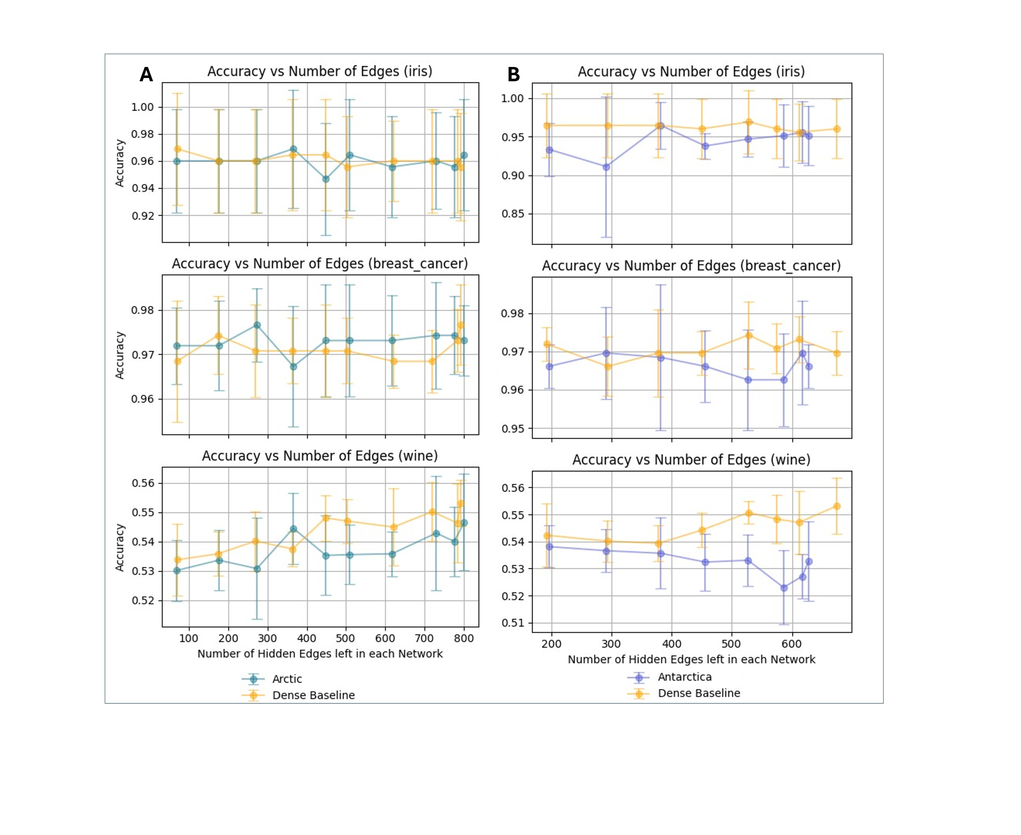

**Figure 3**: Neural network accuracy with respect to remaining edges throughout lowest-KSI dynamic extinction events. Error bars on each point span one standard deviation in each direction. (A) Accuracy of the Arctic network and a baseline network across 3 datasets; (B) Accuracy of the Antarctic network and a baseline network across 3 datasets. Note that extinction by node does not imply linear extinction of edge counts.

Figure 3 presents the accuracy in neural network testing for each trophic web and its respective baseline dense network component. It is important to note that, due to the cycles in the Antarctic web, trials of 10% species left could not be run because insufficient apex predators were left: they were left in a cycle where no outlet for data flow was enabled.

For the Arctic network and baseline, accuracy for the “wine” dataset followed a decline with respect to reducing the number of hidden edges—a decline not seen in the Antarctic network and baseline. Across both the Antarctic and Arctic webs, the other two datasets, “iris” and “breast_cancer” did not cause a notable trend in accuracy with respect to edge count within the tested span of hidden edges.

Observing the Arctic network results, it appears that it remained competitive with the baseline dense network in all tests and throughout all extinctions. In fact, between 770 and 450 edges for the “breast_cancer” dataset, it performed consistently better than the baseline network. However, with the “wine” dataset, the Arctic network performed noticeably worse almost at all points, except right when it had nearly 360 edges left, at which point it superseded the baseline network in accuracy.

Observing the Antarctic network results, the Antarctic network performed noticeably worse than its dense counterpart across almost all tests and all datasets. For the “iris” dataset, it was able to tie the baseline network’s accuracy at two points. For the “breast_cancer” dataset, the Antarctic network rendered only one point that performed better than the baseline network. For the “wine” dataset, all the accuracy points of the Antarctic network were below those of the baseline network. However, with the “wine” dataset, the margin of performance away from the baseline network decreased as the total edge counts decreased.

Across all the tests, the largest gap in mean results between any of the trophic networks and its baseline counterpart was less than 3%.

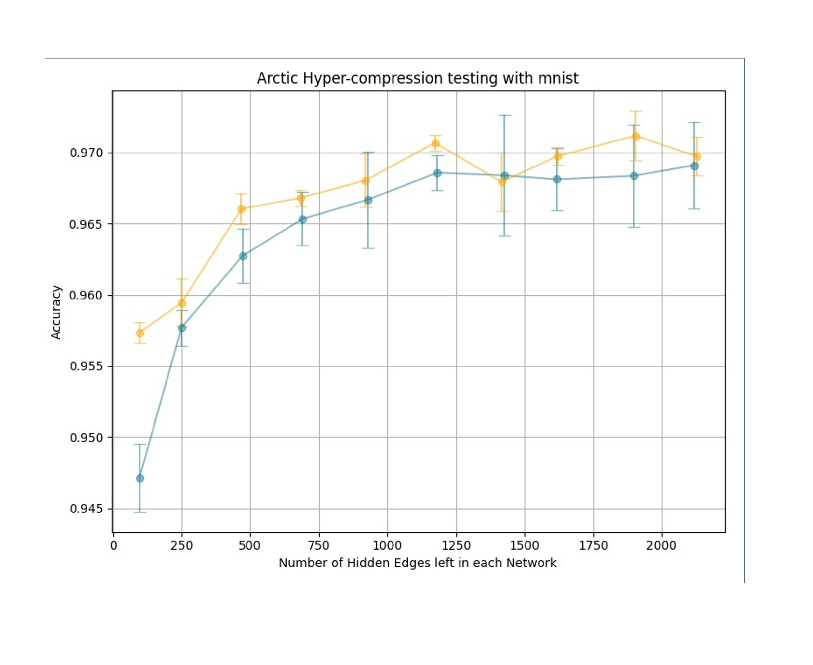

**Figure 4**: Arctic network and baseline network accuracy with respect to remaining edges throughout lowest-KSI dynamic extinction events (<20% original trophic network left). Error bars on each point span one standard deviation in each direction.

When testing much higher levels of compression for just the cascaded Arctic neural network (testing when only 20% to 2% of the network was left), both the baseline network and Arctic network declined notably in performance during compression. At all points, except when around 1400 edges were left, the mean baseline accuracy was greater than the Arctic.

Particularly with this dataset, during training, the Arctic network would typically achieve an even lower loss than the baseline network, followed then by a sharp spike up in loss which would proceed to decline again—much like a sawtooth wave. As such, dependent on the trial number, the Arctic ended with a noticeably different loss than the baseline net.

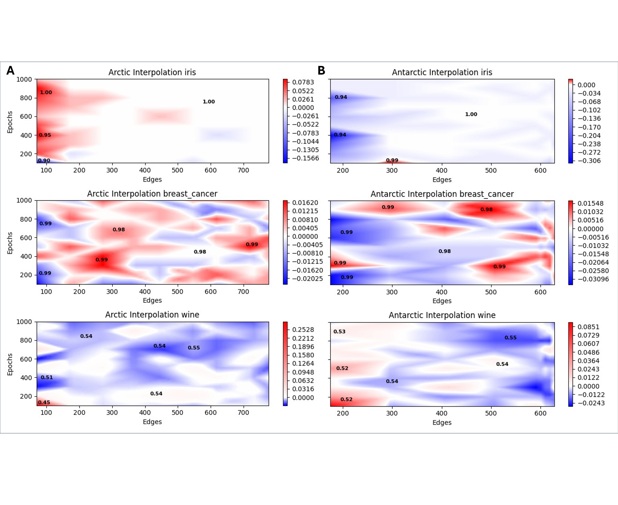**Figure 5**: Accuracy-difference maps (with interpolation) between each trophic network and baseline network testing across different edge counts and training epoch counts. Red indicates better performance by the trophic network; blue indicates better performance by the baseline network. The values of said differences are provided by each respective color bar. Labels of the max accuracy of the best network are annotated in certain notable regions. (A) Accuracy-difference map between Arctic network and baseline network; (B) Accuracy-difference map between Antarctic network and baseline network.

When adding the dimension of the number of epochs that each model trains for, and then only considering the best model generated across each set of 3 trials, much more varied results are revealed. Observing results for the Arctic network with the “wine” dataset, consistent with Figure 3, this trophic web network performs poorer across the board compared to the dense baseline—the only case in which the Arctic outperforms is in a very small region at the lowest edge count and epoch count, which already has a low accuracy compared to the neighboring regions. However, for the “breast_cancer” and “iris” datasets, the Arctic network obtained significantly larger regions of superior performance to the dense baseline—in the “breast_cancer” test, between 150 and 500 edges, and 200 to 1000 epochs, the Arctic network dominantly outperforms the baseline network. However, the best accuracies attained here are akin to the accuracies of the most compressed baseline models that outperform the Arctic web at maximum compression (100 edges left). The most notable results come the “iris” dataset at maximum compression: except at the lowest epoch count, the Arctic network consistently outperformed the dense network and achieved consistently better maximum accuracies than the baseline network in the lowest-epoch corner.

Observing the results for the Antarctic network, there are many more blue regions visible across the board than in the results of the Arctic network, aligned with the results in Figure 3. In the case of the “wine” dataset, the best models are overwhelmingly from the dense baseline, except for the best high-compression and shortest-trained models (bottom-left corner) corresponding to the Antarctic network. Notably, the best accuracy of this corner was only 3% off the best accuracy in the opposite corner (top-right), which was trained for 10 times as long with more than 2.5 times as many edges. In the case of the “breast_cancer” dataset, again, most of the best models were generated by the dense baseline—except for in the 900-1000 epoch band, where many of the best models come from the Antarctic network. Additionally, with the “breast_cancer” dataset, the Antarctic network has two more small but dominant regions, one with low training and low complexity (right above the bottom-left corner), and one with low training and high complexity (bottom-right region). In the “iris” dataset, the Antarctic network underperformed, with only one spot of superior performance (at 300 edges - 100 epochs) yet without notably greater accuracy for the region.

1. ***Discussion***

At first glance, Figure 3 paints a grim picture for the trophic web neural network viability—in the case of the Antarctic, the trophic network is consistently worse, and for the Arctic, there is a very particular stretch for the “breast_cancer” dataset in which the Arctic outperforms the dense baseline. However, it is important to consider these graphs in context—the Antarctic graph is essentially a recurrent neural network, which is much better suited for time-series data and can even struggle with overfitting (Cao et al., 2021) when applied to non-sequential classification tasks. The Arctic network kept up with the dense baseline with “iris” and “breast_cancer”, with the holdup being on the “wine” dataset as also with the Antarctic graph. The “wine” dataset deviated from the typical classification task, as it consisted of a singular output neuron predicting an integer rating by rounding. This categorically different task thus does not take away from the one-hot classification capabilities expressed by both trophic web networks. As a basis, Figure 3 showcases that these trophic web networks can correctly function as neural networks and that more tests need to be conducted to identify their applications. In Figure 4, the investigated application was whether the Arctic network could compress at high volumes efficiently and retain better accuracy in a complex task, such as with MNIST handwritten digit classification. With respect to the baseline network, the Arctic network underperformed in this test.

However, when considering the dimension of training time (by epoch) in Figure 5, it is apparent that the Arctic web does excel in other compression tasks, particularly for simpler machine learning datasets like “iris”. With this dataset, even at maximum compression when training for over 200 epochs, the Arctic accuracy consistently outperforms that of the baseline network, even reaching 100%. Likewise, in the “breast_cancer” dataset, which still presents a relatively simple classification task, the Arctic network overperforms in a wide range of conditions, showing it to be competitive if not better than a dense network across the board. The Antarctic network, when tested with respect to epochs as well, had niche applications in which it outperformed the dense baseline, but nowhere near as broad as the Arctic network. Much like Figure 3, Figure 5B showcases the Antarctic’s ability to nonetheless function as a traditional feed-forward network when having a recurrent architecture, albeit inferiorly.

When looking at the DAG (Arctic) and cyclical (Antarctic) neural network equivalents comparatively, it is apparent that the non-DAG network consistently underperforms its baseline than the DAG networks. Attributing this to the cyclical nature of the Antarctic network, it is apparent that not only does the cyclical nature bias the KSI values within the Antarctic trophic web, but it also alters the nature of energy and information flow. While the Antarctic has energy and information sinks resemblant of a recurrent neural network, such flow straight through the Arctic web like a classical feed-forward network.

From what is investigated within this work, DAG trophic web neural networks could have applications in edge computing and IoT on-device deployment of very-small networks working with simple data streams, like the “iris” and “breast_cancer” tasks. Due to their asymmetric shape, these neural networks require sequential processing to solve for outputs –whether through iterative matrix multiplications or node-by-node processing—which often is the constraint that microcontrollers in edge devices work on.

The efficiency that the DAG trophic web networks have exhibited with respect to training shows that, with fixed architecture, these models could be trained on edge devices with low epoch counts and even retrained if a has changed— and demand for these types of models is widespread (Khouas et al., 2024). For example, say an input signal required for an internal algorithm has disappeared, gone null, or is sampling inconsistently—this edge device could train a trophic neural network quickly and with low complexity to actively solve for this missing signal, or at least provide a viable alternative for the internal algorithm. Moreover, these very-small DAG trophic networks could be trained on the fly in edge devices to emulate Look Up Tables and speed up repeated operations for low memory resource units, as recently investigated by Zehtab et al. (2024).

There is still thorough investigation left to be done into using these trophic web topologies as neural networks. In theory, they bring together many tools sought in specific neural network topologies—built-in recurrent sinks, skip-connections, and feed-forward flow—that could make them capable as multipurpose Swiss-army-knife networks, like with non-layered neuromorphic spiking neural networks (Zou et al., 2021). In the scope of this work, only their feed-forward nature and learning skip-connections are taken advantage of through basic machine learning classification tasks.

In future work, these network topologies should undergo more rigorous machine-learning testing and even testing in edge computing environments—principally, testing the cyclical network in time-series conditions. Moreover, it would be ideal to develop a software tool to stochastically create food web topologies based off of these original structures, similar to the trophic randomization algorithms used in Rodriguez et al. (2022), both to statistically find the significance of the accuracy of these topologies in machine learning applications and to flexibly reshape a food web neural network to the specifications of a specific task. Such a stochastic generation could intentionally mimic the modularity, cycle positions and lengths, apex and basal species counts, and trophic skip-connections of an original food web.

Many works, such as Yu et al. (2022), also investigate sparse-connection routes of dense networks in current machine-learning applications to reduce total computational complexity. In some capacity, sparse networks can be seen as adjacent to DAG trophic web networks in their spread of complexity. Future works may mimic extinction techniques used in this work for dense networks to identify optimal sparse-firing-routes. Note that extinction by minimum KSI cannot be used with a layered setup, but a related keystone index could be made considering weight values and activation functions.

1. ***Joint Conclusion***

Through broad level metrics, node property distributions, and extinction responses, the Antarctic food web of Potter Cove was found to be more resilient than the Arctic food web of Kongsfjorden. The Antarctic web was characterized by having a higher connectivity, denser trophic distribution towards lower trophic levels, and a smoother KSI distribution, all of which allowed it to consistently outlive the Arctic web when faced with varied dynamic extinction events. The novel dynamic extinction method utilized in this work allowed for active restructuring of each web during the extinction process –particularly fluctuations in KSI and trophic level—thus providing a more realistic view of a static graph. These simulations further demonstrated that these webs aren’t purely polar opposites—for example, both webs exhibit high dependence on Detritus, as it was this node that resulted in many of the largest species count drops. These simulations also demonstrated that KSI is not a comprehensive metric for the importance of nodes—even when dynamically evaluated, many low-KSI players were able to cause the largest species count drops. Moreover, these simulations showed that KSI can be biased due to the presence of cycles that, when broken, can result in drastic KSI drops. Finally, it was found that extinction by low KSI was able to maintain the backbone of each graph and emphasize key species, serving as inspiration for using this as a method for topological compression of neural networks. This work puts forward another perspective on the apparent differences between Antarctic and Arctic food webs and intends to inspire investigation into novel extinction modeling techniques.

When modeling both priorly investigated trophic webs as neural network architectures –removing cannibalistic relations and artificially normalizing input-output counts– initial testing rendered these recurrent and feed-forward networks generally inferior to a densely connected baseline when using extinction-compression. Further testing with much higher compression levels in a more complicated task validated this perception with the acyclical network. However, when adding the dimension of training time, it was found that the feed-forward trophic architecture was able to outperform the dense baseline in high compression regions with moderate training length for very simple classification tasks and outperform in moderate compression moderate training regions for higher-feature classification tasks. The disparity in performance for the enacted tests between the cyclical (Antarctic) and DAG (Arctic) trophic architectures further emphasize the prominence in cycles in the Antarctic trophic web and how it is categorically different than the Arctic in how it transfers energy (or information, in a neural context). Future work is required to understand how the Antarctic neural architecture performs in tasks more relevant to recurrent networks, such as signal processing and time-series classification. Nonetheless, this work contributes to the field of machine learning by investigating both pre-training topological compression techniques inspired by trophic webs and by evaluating how a non-layered and scattered trophic neural network architecture can exhibit suitable complexity for machine learning tasks.

1. ***Acknowledgements***

Perplexity, ChatGPT, and GitHub Copilot were used to assist with code generation, debugging, and literature search for the included work and developing related software tools.

1. ***Ethics Statement***

This work did not involve any human subjects. All data for the included trophic webs and documentation for all used libraries is freely available to the public online.

**Bibliography**

Cao, W., Shi, Y.-Z., Qiu, H., & Zhang, B. (2021). SS-RNN: A strengthened skip algorithm for data classification based on recurrent neural networks. *Frontiers in Genetics, 12*, 746181. <https://doi.org/10.3389/fgene.2021.746181>

Cirtwill, A., Dalla Riva, G. V., Gaiarsa, M. P., Bimler, M. D., Cagua, E. F., Coux, C., & Dehling, D. M. (2018). A review of species role concepts in food webs. *Food Webs, 16*, e00093. <https://doi.org/10.1016/j.fooweb.2018.e00093>

Concepcion II, R., Loresco, P., Bedruz, R. A., Dadios, E., Lauguico, S., & Sybingco, E. (2020). Trophic state assessment using hybrid classification tree–artificial neural network. *International Journal of Advances in Intelligent Informatics, 6*(1), 46–57. <https://doi.org/10.26555/ijain.v6i1.408>

Cordone, G., Marina, T. I., Salinas, V., Doyle, S. R., Saravia, L. A., & Momo, F. R. (2018). Effects of macroalgae loss in an Antarctic marine food web: Applying extinction thresholds to food web studies. *PeerJ, 6*, e5531. <https://doi.org/10.7717/peerj.5531>

Cortez, P., Cerdeira, A., Almeida, F., Matos, T., & Reis, J. (2009). *Wine Quality* [Dataset]. UCI Machine Learning Repository. <https://doi.org/10.24432/C56S3T>

Csardi, G., & Nepusz, T. (2006). The igraph software package for complex network research. InterJournal, Complex Systems, 1695.

Cui, Y., Chun, S.-J., Baek, S. H., Lee, M., Kim, Y., Lee, H.-G., Ko, S.-R., Hwang, S., Ahn, C.-Y., & Oh, H.-M. (2019). The water depth-dependent co-occurrence patterns of marine bacteria in shallow and dynamic Southern Coast, Korea. *Scientific Reports*, *9*, 9176. <https://doi.org/10.1038/s41598-019-45512-5>

De Santana, C., Rozenfeld, A., Marquet, P., & Duarte, C. (2013). Topological properties of polar food webs. *Marine Ecology Progress Series, 474*, 15–26. <https://doi.org/10.3354/meps10073>

Dunne, J. A., Williams, R. J., & Martinez, N. D. (2002). Network structure and biodiversity loss in food webs: robustness increases with connectance. *Ecology Letters*, 5(4), 558–567. <https://doi.org/10.1046/j.1461-0248.2002.00354.x>

Dunne, J. A., Williams, R. J., & Martinez, N. D. (2004). Network structure and robustness of marine food webs. *Marine Ecology Progress Series, 273*, 291–302. <https://doi.org/10.3354/meps273291>

Dunne, J. A., & Williams, R. J. (2009). Cascading extinctions and community collapse in model food webs. *Philosophical Transactions of the Royal Society B: Biological Sciences, 364*(1524), 1711–1723. <https://doi.org/10.1098/rstb.2008.0219>

Fisher, R. (1936). *Iris* [Dataset]. UCI Machine Learning Repository. <https://doi.org/10.24432/C56C76>

Gilarranz, L. J., Rayfield, B., Liñán-Cembrano, G., Bascompte, J., & Gonzalez, A. (2017). Effects of network modularity on the spread of perturbation impact in experimental metapopulations. *Science, 357*(6347), 199–201. <https://doi.org/10.1126/science.aal4122>

GitHub. (2025). GitHub Copilot [AI code completion tool]. <https://github.com/features/copilot>

Griffith, G. P., Hop, H., Vihtakari, M., Węsławski, J. M., Kuklinski, P., & Włodarska-Kowalczuk, M. (2019). Ecological resilience of Arctic marine food webs to climate change. *Nature Climate Change, 9*, 868–872. <https://doi.org/10.1038/s41558-019-0601-y>

Griffith, G., Hop, H., Vihtakari, M., Wold, A., Kalhagen, K., & Gabrielsen, G. W. (2019). Data for Nature Climate Change article "Ecological resilience of Arctic marine food webs to climate change" [Dataset]. Norwegian Polar Institute. <https://doi.org/10.21334/NPOLAR.2019.4A851DD2>

Guimerà, R., & Amaral, L. A. N. (2005). Functional cartography of complex metabolic networks. *Nature*, *433*(7028), 895–900. <https://doi.org/10.1038/nature03288>

He, K., Zhang, X., Ren, S., & Sun, J. (2015). Delving deep into rectifiers: Surpassing human-level performance on ImageNet classification. In *2015 IEEE International Conference on Computer Vision (ICCV)* (pp. 1026–1034). <https://doi.org/10.1109/ICCV.2015.123>

Jiang, C., Jiang, C., Chen, D., & Hu, F. (2022). Densely connected neural networks for nonlinear regression. *Entropy, 24*(7), 876. <https://doi.org/10.3390/e24070876>

Johnson, S., Domínguez-García, V., Donetti, L., & Muñoz, M. A. (2014). Trophic coherence determines food-web stability. *Proceedings of the National Academy of Sciences of the United States of America*, *111*(50), 17923–17928. <https://doi.org/10.1073/pnas.1409077111>

Keyes, A. A., Barner, A. K., & Dee, L. E. (2024). Synthesising the relationships between food web structure and robustness. *Ecology Letters*. <https://doi.org/10.1111/ele.14533>

Khouas, A. R., Bouadjenek, M. R., Hacid, H., & Aryal, S. (2024). Training machine learning models at the edge: A survey. *arXiv preprint arXiv:2403.02619*. <https://arxiv.org/abs/2403.02619>

Landi, P., Minoarivelo, H. O., Brännström, Å., Hui, C., & Dieckmann, U. (2018). Complexity and stability of ecological networks: A review of the theory. *Population Ecology, 60*(4), 319–345. <https://doi.org/10.1007/s10144-018-0628-3>

LeCun, Y., Bottou, L., Bengio, Y., & Haffner, P. (1998). Gradient-based learning applied to document recognition [Paper introducing the MNIST dataset]. *Proceedings of the IEEE, 86*(11), 2278–2324. <https://doi.org/10.1109/5.726791>

Lippl, S., Peters, B., & Kriegeskorte, N. (2023). Iterative convergent computation may not be a useful inductive bias for residual neural networks. *bioRxiv*. <https://doi.org/10.1101/2023.10.13.562196>

Niedzwiedz, S., Schmidt, C., Yang, Y., Burgunter-Delamare, B., Andersen, S., Hildebrandt, L., Pröfrock, D., Thomas, H., Zhang, R., Damsgård, B., & Bischof, K. (2024). Run-off impacts on Arctic kelp holobionts have strong implications on ecosystem functioning and bioeconomy. *Scientific Reports, 14*, Article 30506. <https://doi.org/10.1038/s41598-024-30506-1>

OpenAI. (2025). ChatGPT [Large language model]. <https://chat.openai.com/>

Page, L., Brin, S., Motwani, R., & Winograd, T. (1999). *The PageRank citation ranking: Bringing order to the web* (Technical Report No. 1999-66). Stanford InfoLab. <https://ilpubs.stanford.edu:8090/422/>

Paszke, A., Gross, S., Massa, F., Lerer, A., Bradbury, J., Chanan, G., Killeen, T., Lin, Z., Gimelshein, N., Antiga, L., Desmaison, A., Köpf, A., Yang, E., DeVito, Z., Raison, M., Tejani, A., Chilamkurthy, S., Steiner, B., Fang, L., Bai, J., & Chintala, S. (2019). PyTorch: An imperative style, high-performance deep learning library. *arXiv preprint arXiv:1912.01703*. <https://doi.org/10.48550/arXiv.1912.01703>

Pawluczuk, Ł., & Iskrzyński, M. (2023). Food web visualisation: Heat map, interactive graph and animated flow network. *Methods in Ecology and Evolution, 14*, 57–64. <https://doi.org/10.1111/2041-210X.13839>

Pedregosa, F., Varoquaux, G., Gramfort, A., Michel, V., Thirion, B., Grisel, O., Blondel, M., Prettenhofer, P., Weiss, R., Dubourg, V., Vanderplas, J., Passos, A., Cournapeau, D., Brucher, M., Perrot, M., & Duchesnay, É. (2011). *Scikit-learn: Machine learning in P ython*. Journal of Machine Learning Research, *12*, 2825–2830.

Perplexity. (2025). Perplexity AI [Large language model]. <https://www.perplexity.ai/>

Rodgers, N., Tiňo, P., & Johnson, S. (2023). Influence and influenceability: Global directionality in directed complex networks. *Royal Society Open Science, 10*, 221380. <https://doi.org/10.1098/rsos.221380>

Rodriguez, I. D., Marina, T. I., Schloss, I. R., & Saravia, L. A. (2022). Marine food webs are more complex but less stable in sub-Antarctic (Beagle Channel, Argentina) than in Antarctic (Potter Cove, Antarctic Peninsula) regions. *Marine Environmental Research, 174*, 105561. <https://doi.org/10.1016/j.marenvres.2022.105561>

Salinas, V., Cordone, G., Marina, T. I., & Momo, F. R. (2024). Estimating the impact of biodiversity loss in a marine Antarctic food web. *Diversity, 16*(1), 63. <https://doi.org/10.3390/d16010063>

Sayama, H. (2021). *17.05: Degree distribution*. In *Introduction to the modeling and analysis of complex systems*. LibreTexts. <https://math.libretexts.org/Bookshelves/Scientific_Computing_Simulations_and_Modeling/Introduction_to_the_Modeling_and_Analysis_of_Complex_Systems_(Sayama)/17:_Dynamical_Networks_II__Analysis_of_Network_Topologies/17.05:_Degree_Distribution>

Scian, M., Riccialdelli, L., & Marina, T. I. (2025). Food web structure and species’ role in the sub-Antarctic Marine Protected Area Yaganes. *Polar Biology, 48*, 49. <https://doi.org/10.1007/s00300-025-03368-8>

Serrano, M. Á., Boguñá, M., & Vespignani, A. (2009). Extracting the multiscale backbone of complex weighted networks. Proceedings of the National Academy of Sciences, 106(16), 6483–6488. <https://doi.org/10.1073/pnas.0808904106>

Valls, A., Coll, M., & Christensen, V. (2015). Keystone species: Toward an operational concept for marine biodiversity conservation. *Ecological Monographs, 85*(1), 29–47. <https://doi.org/10.1890/14-0306.1>

Winiwarter, P. (2007). *From trophic webs and hierarchical energy transformation systems to multilayer neural networks*.

Wolberg, W., Mangasarian, O., Street, N., & Street, W. (1993). *Breast Cancer Wisconsin (Diagnostic)* [Dataset]. UCI Machine Learning Repository. <https://doi.org/10.24432/C5DW2B>

Yu, P., Artetxe, M., Ott, M., Shleifer, S., Gong, H., Stoyanov, V., & Li, X. (2022). Efficient language modeling with sparse all-MLP. *arXiv preprint arXiv:2203.06850*. <https://arxiv.org/abs/2203.06850>

Zehtab, V., Lindell, D. B., Brubaker, M. A., & Brown, M. S. (2024). Efficient neural network encoding for 3D color lookup tables. *arXiv preprint arXiv:2412.15438*. <https://arxiv.org/abs/2412.15438>

Zou, C., Cui, X., Kuang, Y., Liu, K., Wang, Y., Wang, X., & Huang, R. (2021). A scatter-and-gather spiking convolutional neural network on a reconfigurable neuromorphic hardware. *Frontiers in Neuroscience, 15*, 694170. <https://doi.org/10.3389/fnins.2021.694170>

Zucchet, N., & Orvieto, A. (2024). Recurrent neural networks: Vanishing and exploding gradients are not the end of the story. *arXiv preprint arXiv:2405.21064*. <https://doi.org/10.48550/arXiv.2405.21064>